Platform: Unified PRD and Architecture
Owner: Darshan, Co-Founder and CBO, CohortData Status: Draft v1.0, consolidated Replaces: the earlier screen-by-screen draft. Reference screenshots were used only to understand patterns; numbers and sample data in them are ignored. This document contains no timelines.

1. Purpose and Scope
A multi-tenant platform where a parent team (CohortData) creates data collection projects, assigns them to agencies and contributors, assigns quality-check work, posts results, and runs month-end invoicing. Agencies manage their own contributor pools. Contributors collect data and track their work and earnings.
Data types collected: audio, image, video, documents, PDF.
In scope
- Parent team control center: create projects, assign projects, assign QC tasks, post results, month-end invoicing
- Agency portal (white-label capable) and contributor web app
- Collection intake per data type, automated checks, human QC, delivery packaging
- Rate cards, earnings accrual, invoice generation, statements, manual payment recording
- Consent, compliance, audit, notifications, dashboards
Deferred to a later phase: payment gateway and automated payouts (payments are recorded manually for now), client portal, native mobile apps, ML-based contributor matching.

2. Product Principles
- One system of record for projects, people, submissions, quality decisions and money.
- Data-type agnostic core, data-type specific modules for capture, checks and review.
- Two-level approval: the parent team approves an agency for a project, then approves each member for that project.
- Quality before payment: nothing is payable until it passes QC and is not blocked by a flag.
- Consent and privacy by design: no submission is reviewed or delivered without valid consent.
- White-label ready: agency users can be shown only the agency's branding.
- Everything audited: every status change, decision and money movement has an actor, time and reason.

3. Organization, Roles and Permissions
Hierarchy: Platform (parent team) > Agency > Team > Contributor. Direct contributors sit directly under the parent team.
Role | Belongs to | Primary responsibilities
Super Admin | Parent team | Platform settings, all tenants, roles, security, finance override
Project Manager | Parent team | Create and configure projects, assign to agencies and contributors, monitor delivery
QC Lead | Parent team | Create QC tasks, assign reviewers, set sampling, handle escalations and appeals, post results
QC Reviewer | Parent team (or approved agency) | Claim and review submissions, approve or reject with reason
Finance | Parent team | Rate cards, month-end run, invoice review and approval, record payments, adjustments
Agency Owner | Agency | Profile, members, apply to jobs, assign members, view results and invoices
Agency Manager / Team Lead | Agency | Manage members and project teams, track output and quality
Contributor | Agency or direct | Collect data, view feedback, view earnings and statements

Permission summary
Capability | Super Admin | Project Mgr | QC Lead | QC Reviewer | Finance | Agency Owner | Agency Mgr | Contributor
Create or edit projects | Yes | Yes | No | No | No | No | No | No
Assign projects | Yes | Yes | No | No | No | Apply or accept | No | No
Assign members to a project | Yes | Yes | No | No | No | Submit | Submit | No
Create and assign QC tasks | Yes | No | Yes | No | No | No | No | No
Review submissions | Yes | No | Yes | Yes | No | No | No | No
Post results | Yes | Yes | Yes | No | No | No | No | No
Run month-end invoicing | Yes | No | No | No | Yes | No | No | No
View own earnings and invoices | Yes | No | No | No | Yes | Yes | Limited | Yes
View raw media | Yes | Yes | Yes | Yes | No | Policy based | Policy based | Own only

4. End-to-End Workflow
- Setup: parent team configures organization settings, taxonomies, reason codes, consent templates, rate cards and storage regions.
- Onboard agencies and contributors: profile, verification documents, tax details, members by invite or CSV.
- Create project: data type, requirements, targets, quotas, consent, rates, visibility.
- Assign project: invite agencies, accept applications, or assign directly; then approve members per project.
- Collect: contributors capture or upload through the web app, batch upload or public links.
- Automated checks: format, quality, duplicate and safety checks run per data type.
- QC: QC tasks are created and assigned to reviewers; reviewers claim, review, approve or reject with structured reasons.
- Post results: accepted and rejected results with reasons are published to agencies and contributors.
- Deliver: accepted data is packaged with a manifest for the client.
- Month-end invoicing: the period is closed, earnings are computed from approved work and rate cards, invoices are generated, reviewed, approved and issued.
- Record payment: finance records payment manually with reference and date. Gateway payouts come later.

5. Parent Team Control Center

5.1 Create Project
- Fields: name, client, description, data type (audio, image, video, document, PDF, or mixed), instructions and guidelines (rich text, files, example media), languages and regions, eligibility rules, visibility (public to eligible agencies, invite-only, direct only), status.
- Collection requirements per data type: see Section 7. Includes script or prompt sets, technical limits, device and environment rules, duration, page counts, accepted formats.
- Targets and quotas: total target by count or duration or pages, plus quota cells by segment (for example age band, gender, region, language, device, document category), with per-agency and per-contributor limits.
- Consent: select a versioned consent template and region-specific terms; contributors must sign before first submission.
- QC configuration: automated check set, human review rate (full or sampled), second-review rules, rubric, rejection reason set, turnaround target.
- Commercials: rate card per unit (per item, per audio or video minute, per page), bonus and penalty rules, billing cycle settings, currency.
- Lifecycle: draft, published, paused, completed, archived. Edits to published projects are versioned and logged; delete is archive with reason.
- Cloning: duplicate a project as a template for repeat campaigns.

5.2 Assign Project
- To agencies: publish to eligible or invited agencies; agencies apply; the parent team approves or rejects with reasons. Direct assignment is also available.
- To members: the agency submits members for the project; the parent team (or an auto-rule) approves or rejects each, with reason codes and resubmission. Only approved members can open the project and collect.
- To direct contributors: invite or assign directly under the parent team.
- Eligibility checks shown before submission: verification status, language, country, qualification, quality score, existing load.
- Capacity controls: slot quota per agency, daily and weekly limits per contributor, pause or remove a member from a project with handling for unpaid work.
- Assignment history is logged per project.

5.3 Assign QC Tasks
- QC task creation: automatic when a submission passes automated checks, or manual by QC Lead (select by filter, batch, collector or sample).
- Assignment: to a reviewer, a review team or a pool; modes are manual assignment, round robin, workload balanced, and claim from queue. Language and data-type skills drive eligibility.
- Claim and lock: a reviewer claims an item; locks time out and release automatically.
- Sampling: full review, percentage sampling, higher sampling for new contributors, second review on a sample of approved items, and mandatory second review for flagged items.
- Review workspace: media viewer for the data type, metadata panel, consent status, automated check results, duplicate matches, structured rejection reasons with standard fix instructions, notes, keyboard shortcuts, and next-item navigation in the filtered queue.
- Escalation and appeals: escalate to QC Lead; collectors or agencies can appeal a rejection within a configured window.
- Reviewer performance: throughput, agreement with second reviews, turnaround, overturn rate.

5.4 Post Results
- Result states per submission: approved, rejected, resubmit requested, on hold (flag or consent issue).
- Posting: QC Lead or Project Manager publishes results in batches or continuously; contributors and agencies see status, structured reason, fix instruction and trend charts of top rejection reasons.
- Result reports per project, agency and contributor: counts, duration or pages, approval rate, rejection reasons, turnaround, quality score.
- Quality scoring: each contributor and agency has a score that can unlock bonuses, trigger warnings, throttle or pause submissions.
- Visibility rules: agencies see aggregates and their members' items; raw media access follows project policy; reviewer identities are shown by role only.
- Notifications on results posted, rejections, appeals decided, and quality warnings.

5.5 Month-End Invoicing
- Period close: Finance selects the billing period and closes it; items approved after the cutoff roll to the next period. Closed periods are locked.
- Earnings computation: approved (and delivered, if the project requires it) items are priced from the project rate card, per agency and per direct contributor; bonuses and penalties are applied; items with open flags, missing consent or disputes are excluded and listed as exceptions.
- Draft invoices are generated per payee and currency with line items by project, batch and unit (items, minutes, pages), quantity, rate and amount, plus adjustments.
- Review: Finance reviews drafts, edits adjustments with reasons, resolves exceptions, and approves in bulk; large amounts follow maker-checker approval.
- Issue: approved invoices get sequential numbers, a PDF, a CSV of lines, a statement and a notification to the payee. Payees can dispute with reasons; credit notes handle corrections.
- Record payment: Finance records payment manually (paid date, amount, method, reference, attachment). Partial payments are supported. Status moves to paid.
- Pre-payment checks: tax form on file, payment details present, verification complete, no open dispute or fraud hold.
- Reports: period summary, payable and paid by payee, aging, margin by project (client rate versus payee rate), exceptions, and reconciliation of invoices to the ledger.
- Later phase: payment gateway integration for payout files, API payouts, webhooks, fees and FX. The invoice and ledger design already carries the needed fields.
Invoice statuses: draft, under review, approved, issued, partially paid, paid, on hold, disputed, void, with credit notes as separate documents.

6. Supporting Modules

6.1 Identity and Onboarding
Email and SSO login, MFA mandatory for parent team and agency owners, role-based access, organization switcher (a person can belong to several organizations), invitations by email, link or code. Profiles capture languages, skills, devices, location and timezone. Verification covers identity (vendor integration), business documents for agencies, tax forms by country, and qualification tests per data type. Fields can be locked after verification; changes go through a reviewed change request.

6.2 Agency Management
Agency application and vetting, contract and rate terms, company profile (legal entity, tax ID, certificates, capacity, languages, domains), payment details, white-label settings (logo, colors, domain, email sender), referral links with attribution, agency-level dashboards, and quality gates that can throttle an agency.

6.3 Contributor Management
Roster with search, filters, tags, saved views, bulk actions, CSV import with row-level validation, exports with audit, statuses (invited, active, suspended, offboarded, banned), per-project assignments, quality and activity history. Identity is separate from membership so one person can belong to several organizations. Duplicate and fraud flags (same device, same payment details) are visible to the parent team.

6.4 Collection Intake
- Capture in the web app: guided capture with consent step, environment checks, prompts or scripts, preview and retake, resumable upload.
- Batch upload: files with a metadata CSV, per-file validation and an import report.
- Public links and sessions: expiring, revocable, quota-limited links for approved contributors; sessions group a contributor's submissions with device and environment context.
- Metadata: declared fields (segment, device, language, category) are compared with extracted technical metadata; mismatches are flagged and corrections are logged.

6.5 Automated Checks
Run asynchronously per data type (Section 7). Outcomes: pass, fail with reason, or flag for human review. Results are stored per submission and visible to QC. Duplicate detection (media hashes, face or voice similarity where consented) blocks delivery and payment until resolved by QC with a recorded decision.

6.6 Delivery
Accepted data is packaged per batch with a manifest (pseudonymized contributor ID, consent reference, metadata, quality scores) and delivered to client storage by signed link or push, with attempt tracking, retries and access logs.

6.7 Dashboards and Reporting
- Parent team: project progress against targets and quotas, throughput, QC queue and turnaround, rejection reasons, agency and contributor quality, delivery status, payables, margins.
- Agency: members, assignments, output, results, rejection trends, invoices and statements.
- Contributor: available projects, task history, feedback, quality score, earnings and statements.
- Exports with permissions and audit; amounts shown in each payee's currency.

6.8 Communication and Support
In-app, email and optional WhatsApp notifications; threaded messages per project and invoice; announcements; support tickets; knowledge base.

6.9 Compliance, Consent and Safety
Versioned consent per project and region stored with timestamp and device; age gate; retention and deletion rules per project; data subject requests (access, deletion, withdrawal) with cascade to deliveries where required; regional storage; encryption; watermarked, non-downloadable review views; full access logs. Face and voice data are treated as biometric data under applicable laws. Fraud controls: device and geo checks, multi-account detection, AI-generated content and replay detection.

6.10 Admin Configuration
Taxonomies (segments, skills, languages, document categories), rejection reason sets with fix instructions, consent templates, QC rubrics, rate cards, notification templates, field lock rules, feature flags, and storage and region settings.

6.11 Audit
Immutable log of logins, permission changes, project edits, assignments, QC decisions, result postings, exports, invoice actions and payment records. Project and submission status logs are viewable in context.

7. Data Type Specifications
Data type | Collection methods | Key metadata | Automated checks | QC criteria | Delivery
Audio | In-app recorder, upload, public link | Language, dialect, speaker segment fields, device, environment, script ID, sample rate, duration | Format, sample rate, clipping, noise level, silence ratio, duration, language ID, duplicate fingerprint | Script adherence, clarity, background noise, correct speaker, no cuts | WAV or FLAC plus JSON manifest
Image | Camera capture, upload, batch | Category, subject, device, resolution, lighting, EXIF, optional location | Format, resolution, blur, exposure, EXIF consistency, perceptual duplicate, face and PII detection, unsafe content | Framing, subject match, clarity, instructions followed | JPEG or PNG plus manifest
Video | Guided capture with prompts, upload, batch | Segment fields, device, duration, resolution, frame rate, codec, accessory, lighting, background | Codec, resolution, frame rate, duration, face detection, liveness, duplicate face, prompt adherence, audio presence | Prompt adherence, framing, lighting, one subject, no occlusion | MP4 plus manifest
Documents | Upload, scan capture, batch | Document category, language, page count, source | Malware scan, format, legibility, OCR confidence, duplicate, PII detection, redaction status | Correct category, completeness, legibility, redaction applied | Original plus extracted text plus manifest
PDF | Upload, batch | Category, language, page count, text layer or scanned, size | Valid structure, encryption check, page limits, text layer detection, OCR confidence, embedded content scan, duplicate | Completeness, legibility, correct category, no sensitive leakage | PDF plus extracted text plus manifest

Mixed projects can combine data types, each with its own check set and rate.

7.1 Metadata Framework
Every project, contributor and submission carries structured metadata. Metadata is schema driven, so each project can switch fields on or off per data type without code changes. It powers filtering, quotas, QC, delivery manifests, exports, invoicing and audit.
Metadata levels
- Project level: schema version, data type, requirements, quota definitions, consent template, rate card.
- Participant level (one record per contributor per project): declared segment, verified languages, consent status.
- Submission level (one record per file): identity, device, environment, technical media fields, check results, review outcome, delivery and payment links.
- Event level: status history and corrections, each with actor, time, old and new value, and reason.
Metadata groups
Group | Fields | Source | Visible to
Identity and source | Submission ID, project, batch, session, file name, file hash, storage class, source (live capture, batch upload, public link), submitted at (UTC) | System | Roles with project access
People and ownership | Collector, agency, referred by, referral code, QC assignee, current step | System and profile | Parent team full; agency own members; contributor own items
Participant segment (declared, consented) | Gender, age group, skin tone, nationality, native language, other verified languages, country and region, accessory type | Contributor declared, optionally verified | Parent team and QC; agencies see aggregates
Capture environment | Background (indoor or outdoor), lighting condition, noise level, location type, script or prompt ID | Declared plus auto-detected | Parent team and QC
Device | Device class (mobile, laptop, tablet, other), brand, model, OS and version, browser, camera and microphone details | Extracted and declared, with mismatch flag | Parent team and QC
Technical media: audio | Format, codec, sample rate, channels, bit depth, bitrate, duration, loudness, noise level, silence ratio | Extracted | Parent team and QC
Technical media: image | Format, resolution, megapixels, color space, orientation, EXIF fields, file size | Extracted | Parent team and QC
Technical media: video | Container, codec, resolution, frame rate, bitrate, duration, audio presence, file size | Extracted | Parent team and QC
Technical media: document and PDF | File format, page count, file size, text layer present, OCR confidence, detected language, encryption flag, redaction status | Extracted | Parent team and QC
Automated check results | Outcome and score per check, duplicate match score and linked submission IDs, unsafe content and PII flags | System | Parent team and QC
Quality and review | QC score, rubric results, rejection reason code and text, fix instruction, reviewer notes, appeal status | QC | Reason and fix instruction also visible to contributor and agency
Workflow status | Status, status history, delivered count and dates, delivery attempts, payable status | System | Roles with project access, scoped by ownership
Consent | Template and version, signer, signed at, device and network reference, agreement text version, signed PDF, withdrawal status and date | System | PDF to parent team and the contributor
Commercial | Rate applied, unit, quantity, amount, billing period, invoice number and line reference, payment status | System | Finance full; payees see their own
Audit | Created by, updated by, system corrections with before and after values, export history | System | Parent team

Metadata rules
- Schema per project. Each field has a type (text, number, date, single select, multi select, yes or no, taxonomy reference), required flag, source, validation, allowed values, visibility, sensitivity class, lock flag, and whether it is indexed and usable for quotas, filters, exports and manifests.
- Sources and precedence. Values are declared by the contributor, extracted from the file, derived by the system, or entered by QC. When declared and extracted values differ, the system flags a mismatch, applies the configured precedence (usually extracted), and logs the correction with before and after values and a note.
- Sensitive attributes. Gender, age, skin tone, nationality, face and voice are treated as sensitive. They are collected only when the project requires them and consent covers the purpose, shown by permission only, pseudonymized in deliveries, and shown to agencies only as aggregates.
- Editing. Contributors cannot edit metadata after submission except through a correction request. QC can correct with a reason. Locked fields need Admin approval. Every change is versioned.
- Schema versioning. A schema change creates a new version; existing submissions keep theirs, and migrations are explicit.
- Search and filtering. All indexed fields are filterable in the submission list with combined filters, saved views and live counts.
- Quotas. Quota cells are defined on metadata fields and count accepted items; the capture flow can steer or block contributors toward segments that still need data.
- Intake validation. Batch uploads use a metadata CSV validated per row with a row-level error report; the capture flow validates required fields before upload.
- Exports and manifests. Participants export (one row per contributor per project), submissions export (one row per file), and a JSON manifest per delivery batch, with column selection, role-based redaction and audit logging. Client manifests use pseudonymized contributor IDs.
- Retention and deletion. Metadata follows project retention rules. Deletion requests anonymize or remove participant metadata and flag affected deliveries.
- Consent withdrawal (opt-out). When a contributor withdraws consent, the consent record shows the withdrawal status and date, affected submissions move to on hold, and they are excluded from new deliveries and invoicing. QC and Finance see the reason, and the parent team decides recall steps for items already delivered, following the contract.

Data model additions: MetadataSchema, MetadataSchemaVersion, MetadataField, ParticipantProfile (per project), SubmissionMetadata, MetadataCorrection, ExportTemplate, and withdrawal fields on ConsentRecord.

8. Data Model
- Identity and tenancy: User, Organization, Membership, Role, Permission, Invitation, Profile, Verification, Qualification, TaxForm, Document.
- Projects: Client, Project, ProjectVersion, Requirement, Quota cell, Consent template, Rate card, Eligibility rule, Reason code set.
- Assignment: JobAssignment (agency x project), MemberApplication (member x project), StatusHistory.
- Collection: Session, PublicLink, Submission, SubmissionAsset, SubmissionMetadata, AutoCheckResult, DuplicateMatch, ConsentRecord.
- QC: QCTask, Assignment (reviewer), Claim and lock, ReviewAction, ReasonCode, Appeal, Result, QualityScore.
- Delivery: DeliveryPackage, Manifest, DeliveryAttempt.
- Finance: BillingPeriod, EarningLine, Invoice, InvoiceLine, Adjustment, CreditNote, PaymentRecord, LedgerEntry, TaxWithholding, PayoutMethod.
- Platform: Notification, Message, Ticket, ExportJob, ImportJob, AuditLog, Referral, WhiteLabelConfig, Setting, FeatureFlag.
Every row carries a tenant ID; money movements are immutable ledger entries; balances and dashboard figures derive from the ledger.

9. System Architecture
Principles: modular monolith with clear domain boundaries; split media processing and scheduled jobs into separate workers first; API-first so all portals use the same API; event-driven side effects; multi-tenant by design with row-level security.
Layers
- Clients: Parent Team Console, Agency Portal (white-label capable), Contributor Web App with capture, public capture links. One shared design system.
- Edge and access: CDN, WAF, API gateway or backend-for-frontend, authentication (OIDC), role and tenant policy enforcement, real-time channel for queue and notification updates.
- Core domain modules: Identity and Tenancy; Organization and Agency; Project and Templates; Assignment and Eligibility; Collection Intake; QC Engine (queues, claims, sampling, review, results); Delivery; Finance (rate cards, earnings, invoicing, ledger); Notifications and Messaging; Reporting; Compliance and Consent; Audit.
- Async processing: message queue and event bus; media workers per data type (audio, image, video, document and PDF pipelines); duplicate detection service; scheduler for month-end runs, lock expiry and retention jobs.
- Data stores: PostgreSQL for transactional data; Redis for locks, claims, rate limits and caching; object storage with separate buckets for quarantine, raw, processed and delivery; search index; analytics warehouse fed by events; secrets and key management.
- Integrations: identity verification, e-sign, email and messaging, SSO, client storage targets, and later the payment gateway.
- Cross-cutting: encryption, audit, observability, backups, infrastructure as code, CI and CD.
The architecture diagram below shows these layers and the main flows.
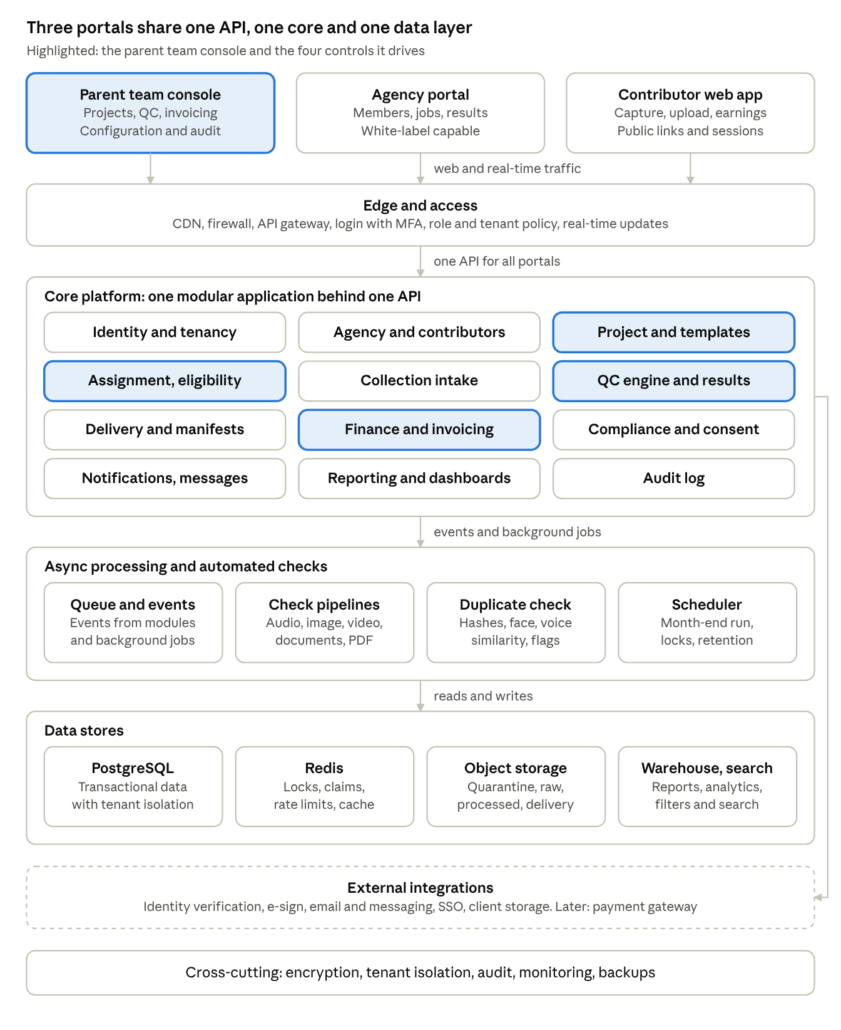
architecture · 3 portals, 5 layers
The parent team console, agency portal and contributor app all call one API. The core modules hand heavy work to async processing, and everything lands in the shared data layer.

10. How the Work Starts: Operating Sequence
- Platform bootstrap: create the parent organization, Super Admin and parent team roles; configure branding, regions and storage, taxonomies, reason codes, consent templates, QC rubrics and notification templates.
- Commercial setup: define rate cards and billing cycle settings; add clients.
- Onboard agencies: invite or accept applications; verify; agree terms; configure white-label if needed; agency adds members.
- Create the first project: configure requirements, quotas, consent, QC, rates; publish to selected agencies.
- Approve agencies and members for the project; contributors sign consent.
- Collection begins: submissions enter automated checks, then the QC queue.
- QC Lead assigns and balances reviewers; results are posted; agencies and contributors act on feedback.
- Delivery to the client begins for accepted data.
- At each month end, Finance closes the period, reviews drafts, issues invoices and records payments.
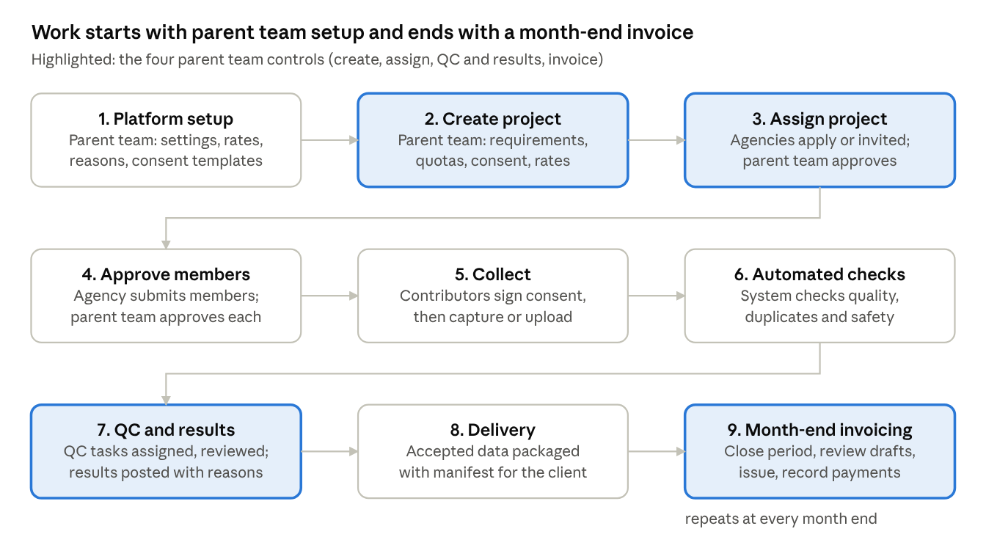
work flow · 9 steps
Steps 2, 3, 7 and 9 are the parent team controls; step 5 is where contributors start producing data.

11. Non-Functional Requirements
- Security: tenant isolation, least privilege, MFA, encryption at rest and in transit, signed short-lived media URLs, malware scanning on all uploads, full audit.
- Reliability: high availability for portals and capture; resumable uploads; idempotent processing; backups with tested restore.
- Performance: fast queue fetch and review loading; server-side pagination and filtering at large scale; background jobs for imports, exports and invoicing.
- Scalability: horizontal scaling of media workers; storage tiering; partitioning of large tables.
- Compliance: GDPR, India DPDP and regional biometric rules; data residency options; retention and deletion automation.
- Usability: responsive web, accessibility, localization, clear empty states and next-action prompts.
- Observability: metrics, tracing, alerts on queue age, failed checks and failed deliveries.

12. Success Metrics
- Approval rate and rejection reasons by project, agency and contributor
- QC turnaround and queue age; reviewer agreement and overturn rate
- Target and quota coverage; delivery completion
- Time from agency application to first approved submission
- Month-end close duration and invoice dispute rate
- Duplicate and fraud detection rate; consent completeness
- Cost per accepted unit and margin per project

13. Scope Boundaries
Included now: everything in Sections 5 to 7, including manual payment recording and statements.
Deferred: payment gateway and automated payouts, client portal, native mobile apps, automated contributor-to-project matching, advanced annotation tooling beyond QC review.

